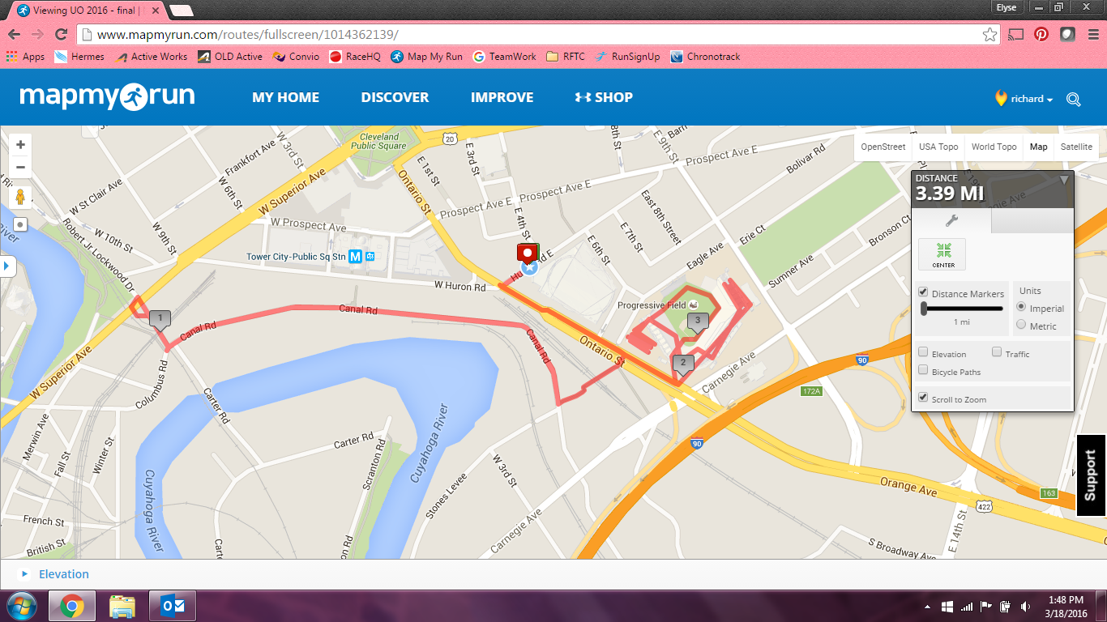

E

G

A

D

D

F

G – Stadium: Ramps Upper Deck, Stairs Lower Deck, Stairs Field

Obstacles in Order of Race:

A – Concrete Barrier Hurdle and Balance Beam (2-way)

B – Stairs (2-way)

C – Bear Crawl (2-way)

D – Tire Carry (1-way)

E – Cars (2-way)

F – Trucks & Pallets

E – Cars

C – Bear Crawl

B – Stairs

A – Concrete Barrier Hurdle and Balance Beam

D

C

B

START on Huron (sidewalk)  
-LEFT on Ontario (sidewalk)  
-Cross Ontario St. to Eagle Ave Ext.  
-Go down stairs to Canal Rd.  
-RIGHT on Canal Rd.  
-RIGHT on Robert J. Lockwood  
Turnaround under bridge  
-LEFT on Canal Rd.  
-Up stairs to Eagle Ave Ext.  
-Cross Ontario and enter Progressive Field at Gate B  
-Run ramps and concourse in Progressive Field  
-Exit Progressive Field at Gate B  
-RIGHT on Ontario (sidewalk)  
-RIGHT on Huron (sidewalk)  
FINISH on Huron (sidewalk)

**FINISH**

**START**